[Smart Mirror Project, Literature Review]

[Reday Yahya]

[Middlesex University London]

[BSc Computing Science]

[01.12.2017]

Index

## Title Page

## Index Page

## Smart Mirror Overview

## Attractiveness Theory

## Attractiveness Rating

## Project Approach

Smart Mirror Overview

What are smart mirrors? smart mirrors are normal mirrors with added technology. Most smart mirror projects are carried out by companies such as Samsung and Panasonic or even individuals and hardware Enthusiasts. In the current market, smart mirrors make a very rare appearance, as there is no clear standard or even a clear product that dominates the scene. However, companies such as Samsung and Panasonic specifically create smaller products and proof of concept models for specific Companies and Electronics Fairs. For hardware fairs and electronic shows Samsung and other smaller companies demonstrate their product that can be potentially introduced to the electronic market, but most of the time it does not enter the market.

Smart Mirrors by Samsung

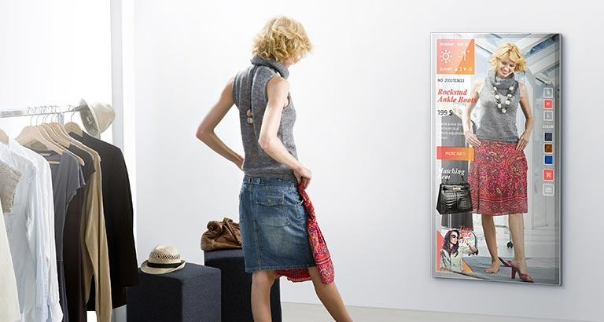Samsung currently makes smart mirrors for the fashion industry and for businesses on demand. Their range varies between different products suited for different needs and tasks. One of their most popular model used and commonly seen during fashion fairs in New York, is the ML55E [1]. This is a very unique piece of Hardware, that focuses on bringing a more digital and interactive way for customers to engage with products. The ML55E portrays the customer in real time like a mirror with capability to overlay anything digitally. This digital content can be anything possible, e.g. information to the product or even any sales advertisement infographics. At fashion shows, this smart mirror has been appearing commonly ever since its official release in 2016. There, the mirror was used differently. Most fashion fairs have utilized the mirror to emulate a cover of a magazine in real time. Paid models, prepared and dressed, then walk up to the mirror setup and then pose in front of it. With a perfect setup that includes good lightning and a suitable background the result does indeed look like a live version of a magazine cover. Fashion experts can then make changes based on what they view and try out different things they wish in real time without making much effort. The hardware in the ML55E is not only used in the ML55E. The main processor used in the ML55E is the same used in their older Smart TV models. The display is a simple 55-inch LED display with a silver reflective coating in between layers and for the connections, it does support every standard connectivity port you can find on a modern TV. The hardware in the ML55E by Samsung is not what makes it unique, its rather the software support that Samsung designed for the product. Samsung provides special designed software to interact with the mirror itself such as an app that runs on Samsung smartphones.

Figure 2 Samsung transparent OLED Mirror | Source: http://www.dailymail.co.uk/sciencetech/article-3118491/Samsung-s-smart-MIRROR-shows-weather-traffic-information-Facebook-notifications-brush-teeth.html

Figure 1. ML55E | Source: <http://displaysolutions.samsung.com/digital-signage/detail/848/ML55E>

However, this is not the only smart mirror Samsung manufactures. Besides the ML55E they have made for the fashion industry, there was one more notable product concept [2] that was demonstrated in South Korea back in 2015. That concept was more advertised towards regular consumers, but it did not enter the market officially. Samsung have used a transparent OLED screen on top of a regular bathroom Mirror.

The Smart Mirror had an overlay and that overlay viewed basic Information, such as time and date, social notifications and calendar event information. Samsung mostly excels with hardware rather than software, this can be seen with most of their products.

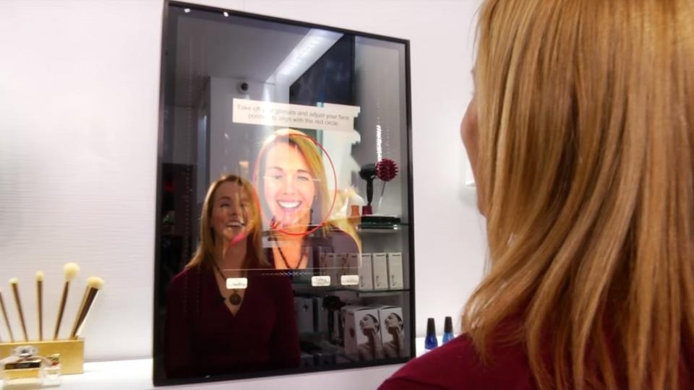Panasonic Smart Beauty Mirror

Panasonic have also made some smart Mirror Products. Their general idea was to improve the general purpose of the mirror in the Bathroom. One of their Mirrors that they have demonstrated at the CEATEC Fair in Japan, was specifically aimed for Makeup and Beauty. The “Beauty Mirror” [3] by Panasonic had multiple features, one of their main core features was to view everything on your face, from Blemishes to dark spots and other unnecessities. This is useful to users, so users can either try to hide it with makeup or try to improve on that area with skincare products that the mirror suggested. The display of the mirror also added white bars on the side of the interface window, this is so the user has a natural source of light shining directly at the face, while the mirror reviews the users face. Besides the beauty feature it also has additional entertaining features, such as “draw on your face” which essentially allows you to draw things like a moustache on your face or try on certain makeup such as lipstick colours and others. This additional feature is not made by Panasonic, but the mirror supports Android apps, the makeup app was made by the makeup company Naked.

Figure Panasonic Smart Beauty Mirror | Source: https://www.forbes.com/sites/karenhua/2016/10/07/panasonic-smart-mirror-shows-you-your-face-flaws-and-helps-you-fix-them/%237f313fd53204

Smart Mirror Project by individuals (DiY Projects)

Inspired by companies and concepts developed by society, hardware enthusiasts have also created their own inspiration of smart mirrors and demonstrated these projects on the internet. These projects are very unique and different from each other. Most projects vary from each other, because they focus on executing different tasks. Therefore, these projects are very interesting to mention, because overall, they also take a giant part of shaping the future of smart mirror products. They demonstrate their own interpretation of what a smart mirror does and should do, and this is where people working in companies and future smart mirror projects get their inspiration from.

The Hardware in these individual projects also varies but the general Idea of the concept is fixed. For a smart mirror, you generally need a computing interface, a reflective mirroring component and a display component. The techniques and component combination can vary, however for the general production of a smart mirror, the concept yet remains a bit similar.

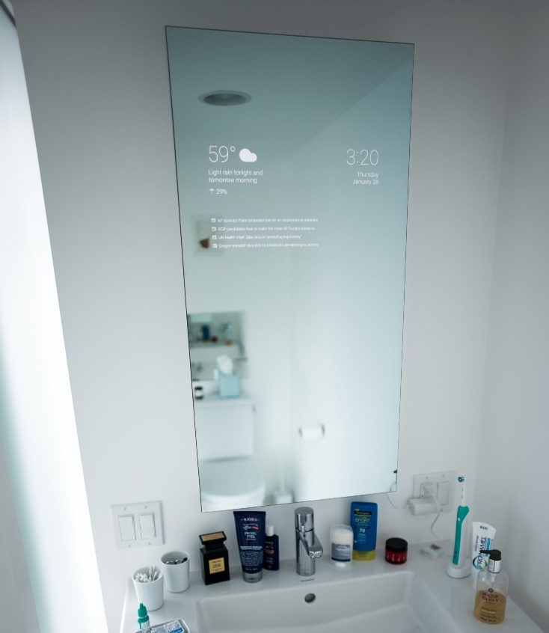On the Internet there are also tools and platforms to develop on. www.[MagicMirror.builders](https://livemdxac-my.sharepoint.com/personal/ry106_live_mdx_ac_uk/Documents/www.MagicMirror.builders), [4] a community for magic mirror software development, have gathered and created the Magic Mirror framework, which is the current popular standard for these projects. Most of these projects use this Development Framework and create features and their own version of it. The framework is developed on JavaScript and is open and publicly available on GitHub. The features developed by individuals presented are very different from what the ML55E and Panasonic beauty mirror does. Their approach is to have multiple features and applications to be supported by their smart mirrors.

Weather it is voice commands via a smart assistant or even something completely different like gesture support, someone may have developed something like this, on a basic level. One of the most common products that is created by hardware enthusiasts is a smart mirror that only displays the needs of basic information during your daily routine at the bathroom. This is where Samsung have gotten their inspiration of their OLED smart mirror.

Figure Smart Mirror DIY Project | Source: https://boingboing.net/2016/02/04/diy-smart-bathroom-mirror.html

Attractiveness Theory

Introduction

Why are we looking at mirrors? There are multiple answers to this question, none of them are wrong. Ultimately it can be any reason, but mostly we want to review our attractiveness and view how others see ourselves. The Image we see is then judged by our consciousness and we make decisions based upon that image. We usually change our hairstyle, apply makeup or even consider getting skincare products to improve on our face or other parts on our bodies for the future.

At times after seeing ourselves in mirrors, we ask other people for a second opinion, because sometimes we view ourselves differently based on personality and how we feel on that specific day. We get that second opinion and throw it in our decision-making formula.

People view attractiveness differently and unique, this means that each person on their world has their own general view on attractiveness. This does not mean it is not possible to understand what people generally think is attractive. In the past it has been attempted multiple times by different cultures and people. In the past course of our history, there have been different approaches that try to find a specific way of defining what is attractive or not. As an example, different neuroscientist have their own believes on what features make a face attractive. According to a journal paper by Thornhill and Gangstad (1999, pp. 453), "*facial attractiveness and what people generally find attractive comes from our genes, rather than our psychology*". They believe that people around the world discriminate their potential mates based on attractiveness and we subconsciously influence our psychological view of someone by our genes. From an evolutionary view we subconsciously select someone that might increase our gene propagation. This statement however is very critically viewed because of many reasons. For example, how would this work with people who find someone with the same sex attractive.

For this neuroscientist claim that people get influenced by multiple factors, our genes are partially responsible for our decision, but there are more factors involved. In history certain cultures had their own general opinion on attractiveness. Ancient Greek mythology believed that the more symmetrical the face is of someone, the more attractive that person is. Even in drawings, artists have always aimed to have their drawing of humans to be even and symmetrical. As the public in ancient Greek appreciated artwork more with realistic and beautiful even symmetrical faces. But besides Historical and Genetical factors, a big key to attractiveness is also personal preferences. There is no doubt that every person on this world is unique in their own specific way. People have their own tastes and likes, and it varies from person to person.

Overall searching for a specific formula for overall general attractiveness is very complicated as there are many factors included, however it is not impossible.

Attractiveness Measurement

After going over the historical, psychological and social views on Attractiveness in this review, this part of the document will go over Attractiveness Measurement. As described and reviewed earlier Attractiveness measurement is something quite complex and very difficult to measure, due to the many factors that are involved. For some, it might sound ridiculous that technology is able to measure something controversial and complex as attractiveness, however it has been attempted by others in the past.

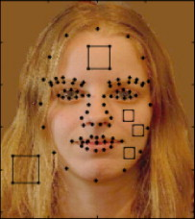At first, before the use of electronical measurement, scientists and researchers have started their research by finding patterns in survey results. This is what Cunningham (1986), has done. Back in 1986 she gave male subjects 50 images of females. The subjects then would have to provide a rating of the features they think is attractive. The most notable features that came across most ratings were:” large eyes, small nose and small chin”. Another few notable characteristics were:” small cheekbones, narrow cheeks and a large smile”. This was also not the only study Cunningham’s team have performed, their second study, based on the results of the first study, have questioned the subjects on what they would have done with the females in the picture and therefore have identified a pattern on what personality type would be most likely to be attracted to other personality types. However, this was only physical measurement performed by individuals who have taken their time to be a subject for testing in a research project.

For something this complex used in modern times, it would simply prove as inefficient in time. A more automated system would prove to be more efficient, as an automated system can simply perform more accurate and faster than humans. Therefore, scientists have started using and developing automated systems to perform these tasks. Distributed systems across multiple areas are also an efficient way to gather information like measurement data from more than just one region. This is also helpful to understand a wider view on capturing the definition of attractiveness and beauty on a global scale.

Figure Facial Data provided by the facial extractor of the machine learning model. | Source: Vision Research.

Kagian et al. (2008) [11], successfully achieved to create a machine learning based model that measures physical attractiveness. This model focuses on identifying patterns across facial images and reveals it via a dataset. This Dataset revealed and marked all points on the image. These markings would reveal anything on the face, both negative and positive. The data from the images would then be taken and compared to a different data set. The second data set would have the images and scores of people that are considered attractive stored. This dataset would also store the average value of an image stored, this will be the value used for comparison against the first dataset. The result proofed that this model was almost exactly like a mean human rating of an individual’s face. It identified the negative and positive features of a face and according to these features, it provided a final measurement score of the face.

Every person on this world has a different face, even twins, while their faces are similar, they do have minor differences that cannot be seen properly the first time we see the person. A system based on machine learning, something what Amit Kagian et al. (2008) [11] and his team have done, seems to offer the right solution to this subject. However, it is not the only solution researchers, developers and scientists have attempted. There were other solutions that offered an alternative to a fully machine learning based system. For example, a group of developers from Akiira Media Systems have developed an artificial intelligence based system that simply takes in raw images of female subjects and offers a human like measurement of given data. Their approach was to simply analyse the image from pixel to pixel and use artificial intelligence to gather information and try to recognize parts of the face. The measurement was scaled to what other subjects have voted to be attractive.

While this seems to be a sophisticated system, this system still has its flaws. One of the main issues this system has, was that the images were limited on what was acceptable or not. Images needed to follow a certain restriction given by the developers for the system to work. Another major issue also was that the system would eventually become outdated. Humanity changes over time, so do our tastes and other parts of our life. The system may proof to be effective in 2010, but may provide inaccurate results in 2018. Therefore, most people working on computational measurement of facial attractiveness choose to develop a system based on machine learning, due to the simple fact that other types of systems need constant adjusting, while machine learning based system constantly learn and improve over time with data added.

Time passes, new technologies get introduced and people improve with their work. The previous projects mentioned were projects from the past, a more recent project by Zhang Lei et al. (2017) and his research team have had a more manual approach. Their developed System was measuring facial attractiveness via facial geometry. The system accepts an image as data, the system lets you select the following “Nose, mouth, ears, eyes and chin”. Through an Image Map, it then measures marked points on the face with the “1:1” geometric even image map. The closer the marked areas are with the image map, the higher the attractiveness score is. Their research provided a dataset and a database that contains the score of the test-subjects. In their research they also describe how attractiveness is all about facial geometry and this is what inspired them to capture computational attractiveness. While this does not really seem like a modern and advanced system, it does do an excellent job of capturing accurate information via manual input. Manual input also prevents potential computational malfunction, which is useful especially with all these other systems that utilize machine learning as their core. While it may prevent potential issues with computational malfunction, it does open the potential of human error. Another issue with this is, that this system does not account for other factors that create “attractiveness”, it simply tries to see if a face is geometrical even. A sophisticated system must account for every bit of detail and not simply one factor.

Most of these research projects have shown clearly that it is possible to measure attractiveness via computational means. The main issue that is seen in these projects, is that attractiveness is not just simply about numbers and calculations. Humanity is individual and different. A huge part in attractiveness is also the individual opinion of a person reviewing what they consider is attractive as in “beauty in the eye of the observer”. Researchers have attempted to bypass this issue with tagged data that then gets sent through a machine learning system. The system would then create a pattern of what people generally think is attractive. However, even with this solution, it can result in inaccurate data. Data can be tagged wrongly and with a bunch of falsely tagged data and then an invalid pattern can be created. Essentially therefore developers and researchers working on computational facial attractiveness use predefined dataset of a specific ethnic to train systems. This dataset would have both “unattractive” and “attractive” image samples and then it would be used to train a machine learning based system.

Reviewing these projects, it turns out that most of these projects create accurate end results, but it simply seems as something is missing to achieve something complete and useable on a day to day basis.

Project Approach to Attractiveness Measurement

For the sake of the project, the attractiveness measurement will focus on facial attractiveness, rather than a full body review. This Project has two possible ways of measuring attractiveness. One approach would be to calculate the average across multiple factors. For an example, you have multiple categories that measure for a certain factor, that measurement is represented by a score given from 1-10. The Average then would be calculated from all categories, and will give an overall score, based on how good someone has scored on the categories. This would be your attractiveness measurement. The benefit of this would be that, based on personal queries, the system would be even able to measure for personal factors and preferences, besides the scientific declared factors. Factors could potentially be “Historical (Greek), Social Definitions and Personal preference “. A Machine however cannot account for Psychological Preferences, so therefore we simply ask the user prefers in facial attractiveness. Since the Users answers are based on thoughts, personal preferences should cover any psychological aspects.

A different approach would be to utilize machine learning to get a grasp what users think is beautiful and ugly. The System would review a bunch of tagged data, that is “attractive” or “not attractive”. After this, the system would then proceed to create a pattern from the facial data acquired, and then be able to decide if the user is attractive or not.

To acquire the tagged data, another source of tagged images would be required. For this a separate application would be beneficial to be developed. The Application would be simple, users would receive different pictures of different users, and the community would then decide if the person in the picture is attractive or not. The Data gathered from the application would allow the system to learn what people think is attractive and then create a pattern for the attractiveness measurement. Another way of acquiring tagged data is to utilize the hotlist of the popular website “hot or not” [14]. “Hot or not” is a website that allows users to rate other users facial image and grade them with a “hot or not” scale of 1-10. The “hotlist” is the list that shows the top candidates with the highest score on the website. The hotlist provides images and score for research purposes, making it an alternative of acquiring tagged data. This data can then be used to train a machine learning based system to create a model of facial attractiveness.

There are many more solutions to measure attractiveness. Machine Learning is usually a high rewarding approach, due to the system evolving after multiple uses, however at the beginning, the system proofs to be mostly inaccurate and after some time of usage it becomes more precise. Where a System that measures a multiple of factors related to attractiveness and then provide a score based on these factors, offers high and accurate data all the time of usage. Both solutions are viable for this project. The next step would then create a platform where this System can perform on.

# References

[1] <http://displaysolutions.samsung.com/digital-signage/detail/848/ML55E> ML55E Smart Mirror by Samsung

[2] <http://www.dailymail.co.uk/sciencetech/article-3118491/Samsung-s-smart-MIRROR-shows-weather-traffic-information-Facebook-notifications-brush-teeth.html> Samsung OLED smart mirror, by Daily Mail.

[3] <https://www.forbes.com/sites/karenhua/2016/10/07/panasonic-smart-mirror-shows-you-your-face-flaws-and-helps-you-fix-them/%237f313fd53204> Panasonic Smart Beauty Mirror, by Karen Hua, 07.10.2016, Forbes.

[4] <https://techcrunch.com/2017/01/17/smart-mirror/> , Brian Heater, 17.01.2017, TechCrunch.com

[5] <https://boingboing.net/2016/02/04/diy-smart-bathroom-mirror.html> Smart Mirror DiY Project example, David Pescovitz, 04.02.2016.

[6] <https://magicmirror.builders/> Michael Teeuw

[7] Randy Thornhill, Steven W. Gangestad, Facial attractiveness, In Trends in Cognitive Sciences, Volume 3, Issue 12, 1999, Pages 452-460, ISSN 1364-6613, <https://doi.org/10.1016/S1364-6613(99)01403-5>. (<http://www.sciencedirect.com/science/article/pii/S1364661399014035>)

[8] Dario Riccardo Valenzano, Andrea Mennucci, Giandonato Tartarelli, Alessandro Cellerino, Shape analysis of female facial attractiveness, In Vision Research, Volume 46, Issues 8–9, 2006, Pages 1282-1291, ISSN 0042-6989, <https://doi.org/10.1016/j.visres.2005.10.024>. (<http://www.sciencedirect.com/science/article/pii/S0042698905005493>)

[9] Swami, V., & Furnham, A. (2008). The psychology of physical attraction. New York: Routledge/Taylor & Francis Group.

[10] Cunningham, M. R. (1986). Measuring the physical in physical attractiveness: Quasi-experiments on the socio-biology of female facial beauty. Journal of Personality and Social Psychology, 50(5), 925-935. <http://dx.doi.org/10.1037/0022-3514.50.5.925>

[11] Amit Kagian, Gideon Dror, Tommer Leyvand, Isaac Meilijson, Daniel Cohen-Or, Eytan Ruppin, A machine learning predictor of facial attractiveness revealing human-like psychophysical biases, In Vision Research, Volume 48, Issue 2, 2008, Pages 235-243, ISSN 0042-6989, <https://doi.org/10.1016/j.visres.2007.11.007>. (http://www.sciencedirect.com/science/article/pii/S0042698907005032)

[12] Lei Zhang, David Zhang, Ming-Ming Sun, Fang-Mei Chen, Facial beauty analysis based on geometric feature: Toward attractiveness assessment application, In Expert Systems with Applications, Volume 82, 2017, Pages 252-265, ISSN 0957-4174, <https://doi.org/10.1016/j.eswa.2017.04.021>. (<http://www.sciencedirect.com/science/article/pii/S0957417417302658>)

[13] Gray D., Yu K., Xu W., Gong Y. (2010) Predicting Facial Beauty without Landmarks. In: Daniilidis K., Maragos P., Paragios N. (eds) Computer Vision – ECCV 2010. ECCV 2010. Lecture Notes in Computer Science, vol 6316. Springer, Berlin, Heidelberg

[14] James Hong. 2000. Meet new People on Hot or Not. [ONLINE] Available at: https://hotornot.com/. [Accessed 01 January 2018].